Tasks | Chapter 2
Student Name | Rawan Abd Elwahab salah
Code | 200279

EXERCISES
- Define the simulation of queue system?
by its Calling Population, the nature of the arrivals, the Service mechanism, the system Capacity and the queuing... discipline

- Draw diagram of Service just completed ?

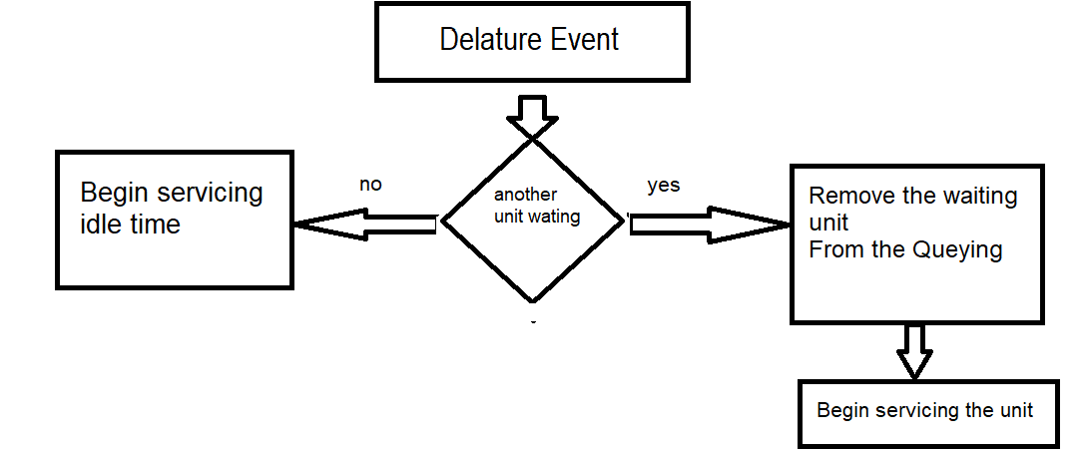
- Draw digram of Unit entering system ?
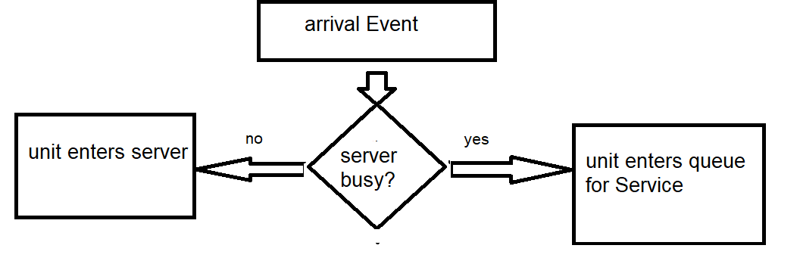
4-Complete the fallowing table and find
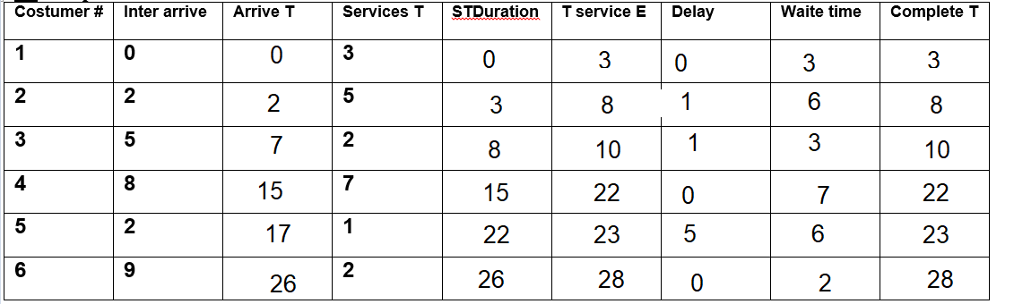

And find:

- average inter =26/6=4.3

- average service time =20/6=3.33

- average delay =7/6=1.16

- average wait =27/6=4.5

- Time spend on the system =28

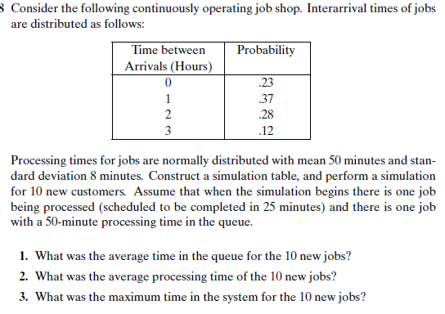

arrival time probability
0 0
60 0.23
120 0.6
180 0.88
<=180 1

arriva interarrival arrival service start time end
job# rand# time time time time in queue time
A given unknown 0 25 0 0 25
B given unknown 0 50 25 25 75
1 0.589 60 60 44 75 15 119
2 0.69 120 180 52 18 0 232
3 0.057 0 180 42 232 52 274
4 0.30 60 240 48 274 34 322
5 0.48 60 300 52 322 22 374
6 0.80 120 420 53 420 0 473
7 0.194 0 420 45 473 53 518
8 0.30 60 480 47 518 38 565
9 0.85 120 600 50 600 0 650
10 0 0.83 120 720 57 720 0 777

The average time in the queue for the 10 new jobs is 21
The average processing time for the 10 new jobs is 49
The maximum time in the system for the 10 new jobs 98

